Cloud Architecture Pattern

Azure Monitoring and logging

# Introduction

Monitoring and logging are crucial for maintaining the performance, security, and compliance of your cloud resources. Azure provides a comprehensive suite of tools designed to help you track and manage these aspects effectively. Whether you're running applications, managing infrastructure, or ensuring security, Azure's monitoring and logging tools offer the insights and controls you need.

# Context

* **Centralize Monitoring:** Collect all your data in one place for easier management.
* **Enhance Security:** Use Sentinel to detect and respond to security threats.
* **Monitor Performance:** Use Application Insights to keep an eye on your application's health and performance.
* **Run Comprehensive Queries:** Use Kusto Query Language (KQL) to analyze data from different sources together.
* **Automate Alerts:** Set up alerts and automated responses to quickly address issues.

# Azure Monitoring and Logging Tools

1. **Azure Monitor (Main Monitoring Solution)**

* Purpose: Collects, analyzes, and responds to telemetry data from Azure and on-premises environments.
* **Key Features:**
  + Application and infrastructure monitoring
  + Log analytics with Kusto Query Language (KQL)
  + Alerts and automated responses
  + Integration with Power BI, Logic Apps
  + external SIEM solutions

2. **Azure Log Analytics (Part of Azure Monitor)**

* **Purpose:** Collects and queries log data from Azure resources, on-prem servers, and hybrid environments.
* **Key Features:** 
  + Centralized log storage and analysis
  + Custom dashboards and reports
  + Uses Kusto Query Language (KQL) for deep insights
  + Integration with Azure Security Center and Microsoft Sentinel

**3. Microsoft Sentinel (SIEM & SOAR)**

* **Context:** Cloud-native SIEM/SOAR solution for security event monitoring and response.
* **Key Features:** 
  + Threat detection and response using AI
  + Security log collection from on-prem, cloud, and third-party tools
  + Built-in dashboards for security insights
  + Incident response automation with playbooks

**Best for security monitoring in cloud & hybrid environments**

4. **Azure Application Insights**

* Purpose: Monitors application performance, exceptions, and dependencies.
* Key Features:
  + Automatic application performance monitoring (APM)
  + Distributed tracing for microservices
  + Error and crash diagnostics
  + Integration with Azure DevOps for CI/CD monitoring

# Architecture

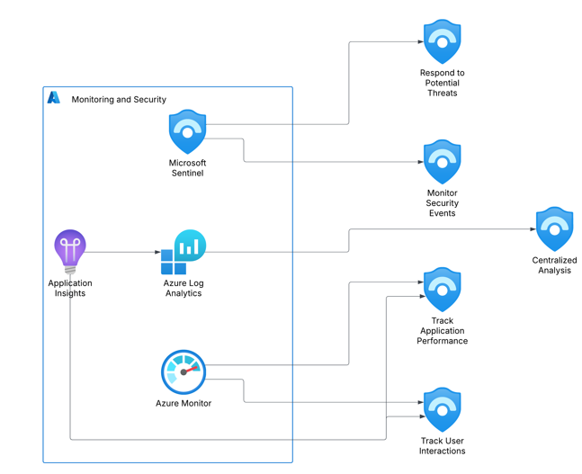

.

# Design Considerations

When designing your monitoring and logging strategy, consider the following:

* **Scope and Scale:** Determine the scope of monitoring (e.g., applications, infrastructure, security) and scale (e.g., number of resources, data volume).
* **Integration:** Ensure seamless integration with existing tools and workflows, such as CI/CD pipelines, security operations, and business intelligence platforms.
* **Automation:** Leverage automation for alerting, incident response, and remediation to reduce manual intervention and improve response times.
* **Customization:** Customize dashboards, reports, and alerts to meet specific business needs and provide actionable insights.
* **Compliance:** Ensure that monitoring and logging practices comply with relevant regulations and standards, such as GDPR, HIPAA, and ISO 27001.